**SMART IRRIGATION SYSTEM USING IOT**

**A PROJECT REPORT**

*Submitted by*

**YOGESHWARI N B 2019504607**

**MANSI A 2019504547**

**JAAJANA G 2019504529**

*In partial fulfilment for the award of the degree*

*of*

**BACHELOR OF ENGINEERING**

**IN**

**ELECTRONICS AND COMMUNICATION ENGINEERING**

**MADRAS INSTITUTE OF TECHNOLOGY**

**ANNA UNIVERSITY: CHENNAI 600 044**

**APRIL 2021**

ANNA UNIVERSITY: CHENNAI 600 044

**BONAFIDE CERTIFICATE**

Certified that this project report, “**SMART IRRIGATION SYSTEM USING IOT**” is the bonafide work of **YOGESHWARI N B (2019504607), MANSI A (201940547), JAAJANA G (2019504529)** **who** carried out the Project work under my guidance.

**SIGNATURE** **SIGNATURE**

**HEAD OF THE DEPARTMENT SUPERVISOR**

**Dr. M GANESH MADHAN Dr.S.EZHILARASI**

Professor and Head Associate Professor

Department of Electronics Department of Electronics Engineering, Engineering,

Madras Institute of Madras Institute of Technology Technology,

Chennai – 600 044. Chennai – 600 044.

ACKNOWLEDGEMENT

We hereby, completing this project, would like to express our very great appreciation to Dr.S.Ezhilarasi and Ms.P.Pavithra for providing required guidance and her valuable and constructive suggestions during our project work. Her willingness to give her time so generously has been very much appreciated.

We would also like to express our gratitude to our faculty for helping us in developing deep insights about our project throughout our learning process. She helped us in bringing out our inquisitiveness towards the concept.

We would also like to thank our friends for their timely help comment and suggestions. Their suggestions and comments had really given me new direction to think on project.

We also thank the HOD,Dr.Ganesh Madhan for giving us the opportunity to carry out a thesis of our choice.

Lastly, we would like to extend our gratitude to authors of the papers and information sources without which this project would not have been possible. The faculty of Madras Institute of Technology have provided us with the knowledge and assistance that constructed the foundation required in us to initiate and follow through a project such as this, and for that we are grateful to all the teachers, officers, and staff of the ECE Department. Finally, we would like to express our gratefulness towards our parents and Almighty for being there with us through thick and thin.

**ABSTRACT**

India’s population has reached beyond 1.2 billion and the population rate is increasing day by day, so after 25-30 years there will be serious problem of food, such that the development of agriculture is necessary. Today, farmers incur the problem of water scarcity due to lack of rain. The project's main goal is to create an automated irrigation system that saves time and money in the long run. The traditional farm land irrigation techniques require manual intervention. With the automated technology of irrigation, the human intervention can be minimized. Whenever there is a change in humidity of the soil, the sensor senses the humidity change and irrigates the field automatically using a popular technology called the ‘Internet of Things’. The project makes use of simple IOT technology and is economic making it feasible even in economically backward areas. This project use various components in this proposed system, such as a soil moisture sensor that senses various soil parameters and send the data to NODEMCU and automatically irrigates the land based on the soil moisture value by turning on and off the motor. The user's android application will show the sensed parameters and motor status.

### TABLE OF CONTENTS

|  |  |  |
| --- | --- | --- |
| **Chapter No.** | **Title** | **Page No.** |
|  | **ABSTRACT** |  |
| **1** | **INTRODUCTION** | 1 |
|  | 1.1 DEFINITION | 1 |
|  | 1.3 WORKING OF IOT | 3 |
|  | 1.4 TECHNOLOGIES USED TO IMPLEMENT IOT | 4 |
|  | 1.5 APPLICATIONS OF IOT | 4 |
|  | 1.6 BENEFITS OF IOT | 5 |
| **2** | **LITERATURE SURVEY** | 6 |
| **3** | **DESCRIPTION** | 8 |
|  | 3.1 INTRODUCTION | 8 |
|  | 3.1.1 SMART IRRIGATION | 9 |
|  | 3.1.2 NEED FOR SMART IRRIGATION | 9 |
|  | 3.1.3 IOT BASED SYSTEM ARCHITECTURE | 10 |
|  | 3.1.4 EXISTING SYSTEM | 11 |
|  | 3.1.5 PROPOSED SYSTEM | 12 |
|  | 3.2 BLOCK DIAGRAM | 12 |
|  | 3.2.1 COMPONENTS | 13 |
|  | 3.2.1.1 MOISTURE SENSOR | 13 |
|  | 3.2.2 ESP8266 nodeMCU | 15 |
|  | 3.2.2.1 ESP-12E Module |  |
|  | 3.2.3 RELAY MODULE | 18 |
|  | 3.2.3.1 FEATURES OF 2-CHANNEL RELAY MODULE | 18 |
|  | 3.2.4 SUBMERISIBLE WATER PUMP | 19 |

|  |  |  |
| --- | --- | --- |
|  | 3.3 WORKING PRINCIPLE | 20 |
|  | 3.3.1 ARDUINO IDE | 20 |
|  | 3.3.2 BLYNK APP | 21 |
|  | 3.3.3 HARDWARE CONNECTIONS | 24 |
|  | 3.4 WORK FLOW | 25 |
|  | 3.5 MERITS & DEMERITS | 25 |
|  | * + 1. MERITS     2. DEMERITS | 25 |
| **4** | **4 RESULTS** | 26 |
| **5** | **5 CONCLUSION** | 28 |
|  | **6 REFERENCES** | 29 |

**CHAPTER-1**

**INTRODUCTION**

* 1. **DEFINITION:**

If an object can connect to the internet, and it’s not a computer or mobile device, it’s a qualifying “thing” in the Internet of Things. These “things” include [wearables](https://www.wareable.com/), [mechanical](https://www.lifewire.com/best-smart-washer-and-dryers-4160413) and [digital](https://internetofbusiness.com/retail-iot-nfc-enabled-pos-terminals-take-off/) machines, even [animals](https://www.postscapes.com/wireless-smart-dog-devices/). In short, to be an IoT device, an object must have two parts:

* + - The object itself
    - A connection to the Internet

Simply connecting an object to the Internet doesn’t necessarily increase its utility, however, so manufacturers generally add in one or both of the following:

1. Sensors, which take in information about the object or its surroundings
2. Actuators, which implement a physical action in the world

To recap, an IoT device is just a non-traditional object connected to the Internet, and it must have at least one sensor or actuator to gain any benefit from this connection.

The Internet of Things (IOT) refers to a system of interrelated, internet-connected objects that are able to collect and transfer data over a wireless network without human intervention. The personal or business possibilities are endless. The Internet of things refers to a type of network to connect anything with the Internet based on stipulated protocols .Through information sensing equipments to conduct information exchange and communications in order to achieve Smart recognitions, positioning, tracing, monitoring, and administration.

From one viewpoint, IOT is simply “more computers,” since it connects previously unconnected “dumb” devices to the Internet. These new devices, however, will have functionality far beyond that of a normal computer. A computer or mobile device is a screen that provides output and a terminal that permits input. Computers and mobile devices can’t have a direct impact on the physical world, which is where IoT devices are revolutionary.

An IOT device can:

1. Intake information without human request
2. Communicate that information to other devices through the Internet
3. Use intelligence (its own or elsewhere) to make decisions
4. Implement those decisions in the real world, either itself or through other Internet-connected devices anywhere on the globe

Since a large portion of IoT’s benefit comes from device interaction and inter- coordination, the whole of IoT is more than the sum of its parts. Just as social media dramatically increased human [connectivity](https://sloanreview.mit.edu/article/social-medias-expanding-relationship-universe/), [communication](http://circaedu.com/hemj/how-social-media-changed-the-way-we-communicate/), and [coordination](https://onlinelibrary.wiley.com/doi/full/10.1111/pops.12478), IoT creates a similar type of revolution through what can be described as a [social network](https://www.youtube.com/watch?v=hFQwip-DUSI) [for machines](https://www.youtube.com/watch?v=hFQwip-DUSI).

### NEED FOR IOT:

Over the past few years, IoT has become one of the most important technologies of the 21st century. Now that we can connect everyday objects such as kitchen appliances, cars, thermostats, baby monitors to the internet via embedded devices, seamless communication is possible between people, processes, and things.

By means of low-cost computing, the cloud, big data, analytics, and mobile technologies, physical things can share and collect data with minimal human intervention. In this hyperconnected world, digital systems can record, monitor, and

adjust each interaction between connected things. The physical world meets the digital world and they cooperate.

Since the 1950s, computers have evolved from mainframes to PCs, then been revolutionized by the spread of the Internet and mobile devices. Currently, the cost of connecting an object to the Internet is [plummeting](https://www.forbes.com/sites/barbarathau/2017/05/15/is-the-rfid-retail-revolution-finally-here-a-macys-case-study/#76e533403294). Since IOT sensors are [already](https://www.ennomotive.com/industrial-iot-sensor-prices/) [inexpensive and only becoming cheaper](https://www.ennomotive.com/industrial-iot-sensor-prices/), many see IOT as computing’s next big step.

**1.3 WORKING OF IOT:**

The basic elements of the IOT are devices that gather data. Broadly speaking,

they are internet-connected devices, so they each have an IP address. They range in complexity from autonomous vehicles that haul products around factory floors to simple sensors that monitor the temperature in buildings. They also include personal devices like fitness trackers that monitor the number of steps individuals take each day. To make that data useful it needs to be collected, processed, filtered and analyzed, each of which can be handled in a variety of ways.

Collecting the data is done by transmitting it from the devices to a gathering point. Moving the data can be done wirelessly using a range of technologies or on wired networks. The data can be sent over the internet to a data centre or a cloud that has storage and compute power or the transfer can be staged, with intermediary devices aggregating the data before sending it along.

Processing the data can take place in data centres or cloud, but sometimes that’s not an option. In the case of critical devices such as shutoffs in industrial settings, the delay of sending data from the device to a remote data centre is too great. The round- trip time for sending data, processing it, analyzing it and returning instructions (close that valve before the pipes burst) can take too long. In such cases edge-computing can come into play, where a smart edge device can aggregate data, analyze it and fashion responses if necessary, all within relatively close physical distance, thereby reducing

delay. Edge devices also have upstream connectivity for sending data to be further processed and stored.

**1.4 TECHNOLOGIES USED TO IMPLEMENT IOT:**

While the idea of IoT has been in existence for a long time, a collection of recent advances in a number of different technologies has made it practical.

* + - **Access to low-cost, low-power sensor technology.** Affordable and reliable sensors are making IoT technology possible for more manufacturers.
    - **Connectivity.** A host of network protocols for the internet has made it easy to connect sensors to the cloud and to other “things” for efficient data transfer.
    - **Cloud computing platforms.** The increase in the availability of cloud platforms enables both businesses and consumers to access the infrastructure they need to scale up without actually having to manage it all.
    - **Machine learning and analytics.** With advances in machine learning and analytics, along with access to varied and vast amounts of data stored in the cloud, businesses can gather insights faster and more easily. The emergence of these allied technologies continues to push the boundaries of IoT and the data produced by IoT also feeds these technologies.
    - **Conversational artificial intelligence (AI).** Advances in neural networks have brought natural-language processing (NLP) to IoT devices (such as digital personal assistants Alexa, Cortana, and Siri) and made them appealing, affordable, and viable for home use.

### APPLICATIONS OF IOT:

IOT Intelligent Applications are prebuilt software-as-a-service (SaaS) applications that can analyze and present captured IoT sensor data to business users via dashboards. Oracle has a full set of IoT Intelligent Applications.

IOT applications use machine learning algorithms to analyze massive amounts of connected sensor data in the cloud. Using real-time IoT dashboards and alerts, you gain visibility into key performance indicators, statistics for mean time between failures, and other information. Machine learning–based algorithms can identify equipment anomalies and send alerts to users and even trigger automated fixes or proactive counter measures.

With cloud-based IoT applications, business users can quickly enhance existing processes for supply chains, customer service, human resources, and financial services. There’s no need to recreate entire business processes.

* 1. **BENEFITS OF IOT:**

The advantages of the Internet of Things (IoT) have changed how SMBs approach the use of devices in the workplace. In today’s digital landscape, devices, machines, and objects of all sizes can automatically transfer data through a network, effectively “talking” with each other in real time.

* + 1. Cost reduction
    2. Efficiency and productivity
    3. Business opportunities
    4. Customer experience
    5. Mobility and agility

# **CHAPTER 2**

# **LITERATURE SURVEY**

1. Author: Aadithyan V, T Sai Samrat Goud, G Karthik Reddy, P Naga Chaitanya, V Jaya Surya, Dr K Prabhakara Rao

The purpose of this paper is to automate the irrigation process in agriculture. This is accomplished by the use of a smart device comprised of NodeMCU, Moisture sensor, and Humidity sensor. The NodeMCU is a microcontroller with a built in Wi-Fi communication module. The Moisture sensor tests the moisture content of the soil and transmits the information to the NodeMCU. Similarly, the humidity sensor measures the level of humidity in the air and sends the data to the NodeMCU. When the NodeMCU receives all of the data, it sends a pulse to the relay module, which then turns on the pump based on the data it has received and the inbuilt data. This removes the need for manual irrigation, enabling farmers to focus their time on other important tasks.

1. Author: .Meghana Gupta Arakere, Avik Seal and Tejomurthula Bhuvana Teja

The concept of this project is to allow the owners of fields to control and observe the growth of their plants in their farms. This is achieved by using a smart platform of IoT and solenoid valves to control the flow of water based on the moisture of the soil and gives real time surveillance to the owners who stay far away from the farms. This project also allows surveillance on the personnel and their crops so as to not occur losses. It is easy to use for anyone with a Smartphone and doesn’t require maintenance once set up.

1. Author: .Pavankumar Naik, Arun Kumbi , Kirthishree Katti, Nagaraj Telkar

An embedded system for automatic irrigation control is part of the proposed work. This project uses a wireless sensor network to track an irrigation system in real time. This method ensures that the agricultural farm receives the exact amount of water it needs and prevents water pollution. When the moisture level in the soil falls below a certain threshold, the machine turns on the engine. When the water level returns to normal, the motor turns off automatically. The motor's current status and sensed parameters will be reflected on the user's Android application.

1. Author: Premalatha C

In this paper, The soil moisture sensor senses the amount of moisture content in the soil which is uploaded to the Arduino board. The Arduino board transfers the control over the system to the relay module which is responsible for switching operations. The relay module ensures proper irrigation of the field turning it on when the value of moisture is below the threshold value and turns off the supply when the moisture content is sufficient for the crop or plant thereby preventing under irrigation or over irrigation. The state of the relay module is indicated by the LED. The working of the system is simple and can be controlled easily.

# **CHAPTER 3 DESCRIPTION**

### INTRODUCTION:

In India, agriculture plays an influential role for development in food production and also for the economy and development of a country. In the agriculture’s field, use of proper method of irrigation plays a paramount role. Indian agriculture is mainly reliant on the monsoon which is not a reliable source of water. Many areas of agricultural fields are effectively over or under irrigated due to spatial variability in water infiltration and runoff of rainfall and irrigation. Under-irrigated areas are subject to water stress, resulting in production loss, while over-irrigated areas suffer from plant disease and nutrient leaching. Relevant soil water level is a mandatory called for optimum plant growth. As, water is a prerequisite element for life sustenance, there is the necessity to avoid its undue usage. Irrigation is a dominant consumer of water, which consumes lot of groundwater. A need occurs to regulate water supply for irrigation purposes.

The manual irrigation has major demerits :

* + - Due to seepage in drains, wastage of water is caused.
    - Machines cannot be used by this method because during spray of insecticides or fertilizers, the earthen walls of basins are damaged.
    - There is imbalance in distribution of labour. After growth of crops, water reaches the basins in disproportionate quantity thereby causing wastage of water.
    - Creation of problem of water logging.

So there is a need to adopt new methods of irrigation.

### SMART IRRIGATION:

Present generation has become smart using technologies. So smart technologies have become order of the day. As the technology is getting advanced everything is becoming automatic and smart in our usage. Using smart devices helps to increase the efficiency which enhances the capability and helps to minimize the cost. Similar to the gadgets what we use in our day to day activities at home in irrigation system also these smart technologies can be adopted then we may permit was Smart Irrigation system. The smart irrigation aims to save time and remove concerns such as excessive vigilance. It also leads to water conservation by automatically watering plants or gardens based on their water needs. When technology advances, there is always the possibility of lowering risks and making work easier. Many problems can be solved using embedded and microcontroller devices. Using a sensor microcontroller device, this programme precisely regulates the water system for gardens. It is accomplished by placing sensors in the field to measure soil temperature and moisture, and then transmitting the information to a microcontroller for estimation of plant water demands.

### NEED FOR SMART IRRIGATION:

Earlier India enjoyed abundant water resources. But now population growth and overexploitation has lead to a situation where there is demand for water. From the survey we can clearly see how the water percentage is reducing year by year from 1960 to present. If the rate continues it leads to water scarcity. So there is an emergency to conserve water . The reason behind this shortage of water is using traditional system of irrigation During traditional system requirement of water to plants is not monitored properly When the soil is moist enough water is still provided to plants. This excess amount of water is not absorbed by the plants and is wasted thus . To monitor the water requirement of the plants a system is needed. Implementing smart irrigation helps to decrease the loss of water caused by using traditional system .

Smart irrigation is a key component of precision agriculture. It helps farmers avoid water wastage and improve the quality of crop growth in their fields by:

* + - * Irrigating at the correct times.
      * Minimizing runoffs and other wastages.
      * Determining the soil moisture levels accurately (thereby, finding the irrigation requirements at any place).
      * Replacing manual irrigation with automatic valves and systems also does away with the human error element (e.g. forgetting to turn off a valve after watering the field), and is instrumental in saving energy, time as well as resources.
      * The installation and configuration of smart irrigation systems is, in general, fairly straightforward too – which helps the average user.

### IOT BASED SYSTEM ARCHITECTURE:

A smart microcontroller (which serves as the ‘information gateway’) lies at the heart of the automated irrigation infrastructure. Soil moisture sensors and temperature sensors, which are placed on the fields, send real-time data to the microcontroller. Generally, a ‘moisture/temperature range’ is specified, and whenever the actual values are out of this range, the microcontroller automatically switches on the water pump, which is mounted on it with output pins. The microcontroller also has servo motors to make sure that the pipes are actually watering the fields uniformly so that no area gets clogged or is left too dry. The entire system can be managed by the end-user through a dedicated mobile application. Smart irrigation makes it possible for growers to monitor and irrigate their fields remotely, without any hassles.

The flow of information to and from the centralized gateway (here, the microcontroller) has to be supported by stable internet services. Wireless low-power networks (e,g., LoRaWAN or Sigfox) can easily be used to power the sensors. These sensors send field information to the local computer of the user or to a cloud network (as required). The system can combine the information with other inputs from third- party services (say, the local weather channel) to arrive at ‘intelligent irrigation decisions.' For example, if rain is in the forecast, water will not be released even if the real-time data suggests that the field needs irrigation. Recalculations are also completed at regular intervals. **Smart irrigation systems can save up to 45 percent water during the dry season, and around 80 percent of water in the rainy season when compared to manually operated watering systems.**

In an automated irrigation infrastructure, there is no room for resource wastage. As a result, there are cost benefits to be gained as well. By replacing the traditional watering system with a fully self-operating one, the chances of crops dying due to excessive (or insufficient) watering are minimal, which means that farmers will not have to worry about frequent plant replacement. Also, since smart agriculture, in general, and smart irrigation is all about faster, healthier crop growth, the average crop cycle is shortened. This means that there are chances of increased annual yields. IoT-powered irrigation tools can be used in lawns, gardens, and landscapes, as well.

* + 1. **EXISTING SYSTEM:**

The threshold value of moisture is not taken into account in most existing systems, and the field is irrigated at random time intervals, resulting in over- or under- irrigation of the field, which affects crop productivity. A method is proposed to monitor the soil moisture and the irrigation is done only when the moisture content goes below the threshold value.

### PROPOSED SYSTEM:

This proposed work includes an embedded system for automatic control of irrigation. This project uses a sensor and Nodemcu to track an irrigation system in real time. This method ensures that the agricultural farm receives the exact amount of water it needs and prevents water waste. When the moisture level in the soil falls below a certain threshold, the machine turns on the engine. When the water level returns to normal, the motor turns off automatically. The motor's current status and sensed parameters will be reflected on the user's Android application.

* 1. **BLOCK DIAGRAM**

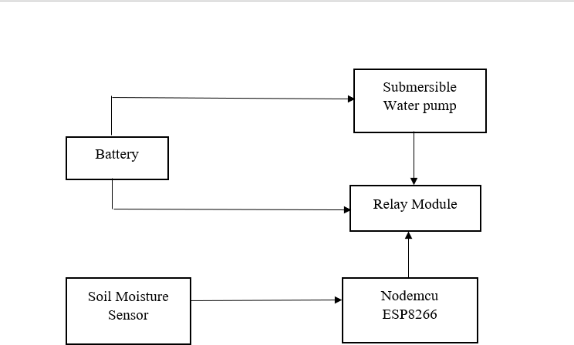

### COMPONENTS:

* + - 1. **MOISTURE SENSOR:**

One of the first things that comes to mind when you hear the word "smart irrigation" is a device that automatically monitors soil moisture and irrigates your plants. You can water your plants only when they need it with this method, avoiding over- or under-watering. You would certainly need a Soil Moisture Sensor if you want to create such a device.

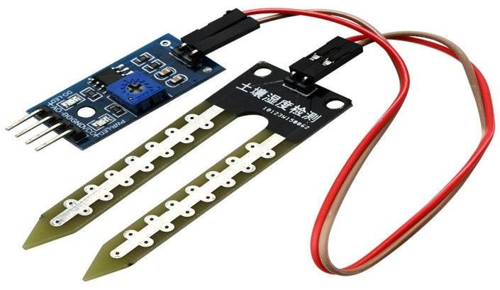

### Fig.3.1 Soil Moisture Sensor

* + - 1. **WORKING OF SOIL MOISTURE SENSOR:**

The fork-shaped probe with two exposed conductors, acts as a variable resistor (just like a potentiometer) whose resistance varies according to the water content in the soil.

This resistance is inversely proportional to the soil moisture:

* + - * + The more water in the soil means better conductivity and will result in a lower resistance.
        + The less water in the soil means poor conductivity and will result in a higher resistance.

The sensor produces an output voltage according to the resistance, which by measuring we can determine the moisture level. A typical soil moisture sensor has two components.

* The Probe
* The Module
  + - 1. **THE PROBE:**

The sensor contains a fork-shaped probe with two exposed conductors that goes into the soil or anywhere else where the water content is to be measured. it acts as a variable resistor whose resistance varies according to the soil moisture.

* + - 1. **THE MODULE:**

The sensor also contains an electronic module that connects the probe to the Arduino. The module produces an output voltage according to the resistance of the probe and is made available at an Analog Output (AO) pin. The same signal is fed to a LM393 High Precision Comparator to digitize it and is made available at an Digital Output (DO) pin. The module has a built-in potentiometer for sensitivity adjustment of the digital output (DO). The values can be set a threshold by using a potentiometer; So that when the moisture level exceeds the threshold value, the module will output LOW otherwise HIGH.

This setup is very useful when you want to trigger an action when certain threshold is reached. For example, when the moisture level in the soil crosses a threshold, you can activate a relay to start pumping water. Rotate the knob clockwise to increase sensitivity and counterclockwise to decrease it. Apart from this, the module

has two LEDs. The Power LED will light up when the module is powered. The Status LED will light up when the digital output goes LOW.

### SENSING SOIL MOISTURE USING ANALOG OUTPUT:

As you know that the module provides both analog and digital output, so for our first experiment we will measure the soil moisture by reading the analog output.

### 3.2.1.5.1 CONNECTION OF SOIL MOISTURE SENSOR WITH NODEMCU:

Let’s hook the soil moisture sensor up to the nodeMCU. First you need to supply power to the sensor. For that you may connect the VCC pin on the module to 3V on the Arduino. However, one commonly known issue with these sensors is their short lifespan when exposed to a moist environment. Having power applied to the probe constantly speeds the rate of corrosion significantly. To overcome this, we recommend that you do not power the sensor constantly, but power it only when you take the readings. An easy way to accomplish this is to connect the VCC pin to a digital pin of an nodemcu and set it to HIGH or LOW as per your requirement . Also the total power drawn by the module (with both LEDs lit) is about 8 mA, so it is okay to power the module off a digital pin on an Arduino. So, let’s connect the VCC pin on the module to the digital pin #7 of an Arduino and GND pin to ground. Finally, connect the AO pin on the module to the A0 ADC pin on your nodemcu.

### ESP8266 nodeMCU:

* + - 1. **ESP-12E Module:**

The development board equips the ESP-12E module containing ESP8266 chip having Tensilica Xtensa® 32-bit LX106 RISC microprocessor which operates at 80 to 160 MHz adjustable clock frequency and supports RTOS**.** There’s also 128 KB RAM and 4MB of Flash memory (for program and data storage) just enough to cope with the large strings that make up web pages, JSON/XML data, and everything we throw at IOT devices nowadays. The ESP8266 Integrates 802.11b/g/n HT40 Wi-Fi transceiver,

so it can not only connect to a WiFi network and interact with the Internet, but it can also set up a network of its own, allowing other devices to connect directly to it. This makes the ESP8266 NodeMCU even more versatile.

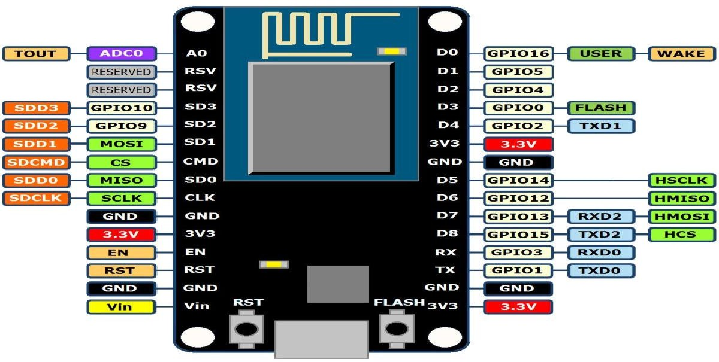

### Fig 3.2 Nodemcu ESP8266

* + - 1. **POWER REQUIREMENT:**

As the operating voltage range of ESP8266 is 3V to 3.6V, the board comes with a LDO voltage regulator to keep the voltage steady at 3.3V. It can reliably supply up to 600mA, which should be more than enough when ESP8266 pulls as much as 80mA during RF transmissions. The output of the regulator is also broken out to one of the sides of the board and labeled as 3V3. This pin can be used to supply power to external components. Power to the ESP8266 NodeMCU is supplied via the on-board MicroB

USB connector. Alternatively, if you have a regulated 5V voltage source, the VIN pin can be used to directly supply the ESP8266 and its peripherals.

17

### PERIPHERALS AND I/O:

The ESP8266 NodeMCU has total 17 GPIO pins broken out to the pin headers on both sides of the development board. These pins can be assigned to all sorts of peripheral duties, including:

* + - * + ADC channel – A 10-bit ADC channel.
        + UART interface – UART interface is used to load code serially.
        + PWM outputs – PWM pins for dimming LEDs or controlling motors.
        + SPI, I2C & I2S interface – SPI and I2C interface to hook up all sorts of sensors and peripherals.
        + I2S interface – I2S interface if you want to add sound to your project.

The ESP8266’s pin multiplexing feature (Multiple peripherals multiplexed on a single GPIO pin). Meaning a single GPIO pin can act as PWM/UART/SPI.

### ON-BOARD SWITCHES & LED INDICATOR:

The ESP8266 NodeMCU features two buttons. One marked as RST located on the top left corner is the Reset button, used of course to reset the ESP8266 chip. The other FLASH button on the bottom left corner is the download button used while upgrading firmware. The board also has a LED indicator which is user programmable and is connected to the D0 pin of the board.

### RELAY MODULE:

The 2-Channel 5V Relay Module is a relay interface board, it can be controlled directly by a wide range of microcontrollers such as Arduino, AVR, PIC, ARM and so on. It uses a low level triggered control signal (3.3-5VDC) to control the relay. Triggering the relay operates the normally open or normally closed contacts. It is frequently used in an automatic control circuit. To put it simply, it is an automatic switch to control a high-current circuit with a low-current signal.5V relay signal input voltage range, 0-5V. VCC power to the system. JD-VCC relay in the power supply. JD-VCC and VCC can be a shorted.

### 3.2.4 FEATURES OF 2-CHANNEL RELAY MODULE:

* Good for safe control of higher amperage circuits. In power systems, the lower current can control the higher one.
* 2-channel high voltage system output, meeting the needs of dual channel control.
* Brand new and high quality.
* Standard interface that can be controlled directly by microcontroller (Arduino , 8051, AVR, PIC, DSP, ARM)]
* Wide range of controllable voltages.
* Being able to control high load current, which can reach 250V, 10A or 125V, 15A
* With a normally-open (NO) contact and a normally-closed (NC) contact.
* Around the board with 4 mounting holes, easy installation and fixing
* It has a common end, a beginning, a closed-end.

18

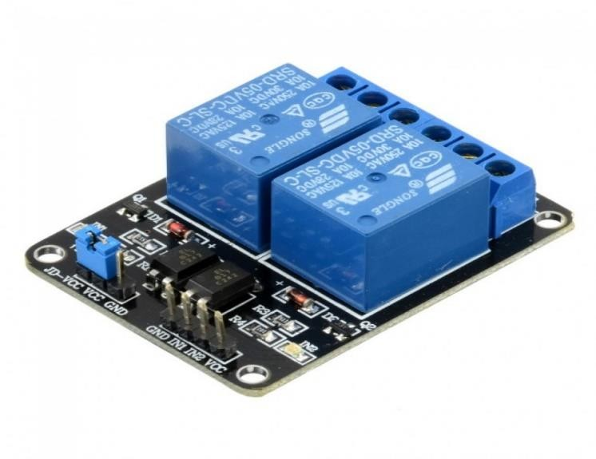

### Fig.3.3 2- Channel Relay Module

* + 1. **SUBMERISIBLE WATER PUMP:**

The Micro Submersible Water Pump DC 3V-5V, can be easily integrate to your water system project. The water pump works using water suction method which drain the water through its inlet and released it through the outlet. Firstly, simply connect the red wire (+) and black wire ( -

) to a 3V or 5V DC supply. Next, make sure the connection is right (+) wire to (+) terminal and (-) wire to (-) terminal. Submerge the water pump into the water according to your application preferences. When the supply is on, water will flow into the inlet of the pump and flow out through the outlet .

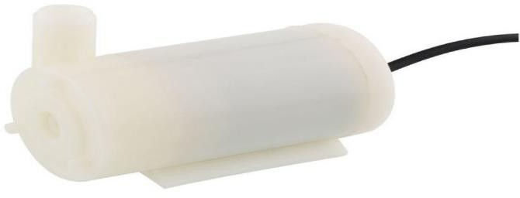

**Fig.3.4 Micro Submersible water pump**

19

## WORKING PRINCIPLE

The connections are made in Bread board. The Nodemcu , soil moisture sensor is placed in the breadboard. The Arduino IDE is installed in PC, the suitable driver (CP2102)is installed and connected with Arduino IDE.

### 3.3.1 ARDUINO IDE:

The first pin of soil moisture sensor is connected to D5 of Nodemcu ESP8266.The third and fourth pin of soil moisture sensor is connected to GND and Vin of Nodemcu. using the USB cable, the Nodemcu is connected to PC. To install libraries: Sketch->Add Library->Manage Libraries->install the ESP8266WiFi.h and BlynkSimpleEsp8266.h Libraries.

To select Board: Tools->Board->Board Manager->select ESP8266 Wifi->close.

The Source code for Smart Irrigation System is compiled and the error is rectified using verify Button. The File is saved as "Smart Irrigation System". To Enable the port in PC: select This PC->Manage->Device Manager->port(COM & LPT)->silicon Labs CP210x USB to UART bridge(COM6)->Update

driver->close. The port is enabled in Arduino IDE.

In Arduino IDE select Tools->Board:->ESP8266 Boards(2.7.4) ->NodeMCU 0.9(ESP-12 Module).

To select Port: Tools->Port->COM6.

upload the code in NodeMCU. click the Upload Button in Taskbar. After few minutes the code is successfully dumped in NodeMCU.

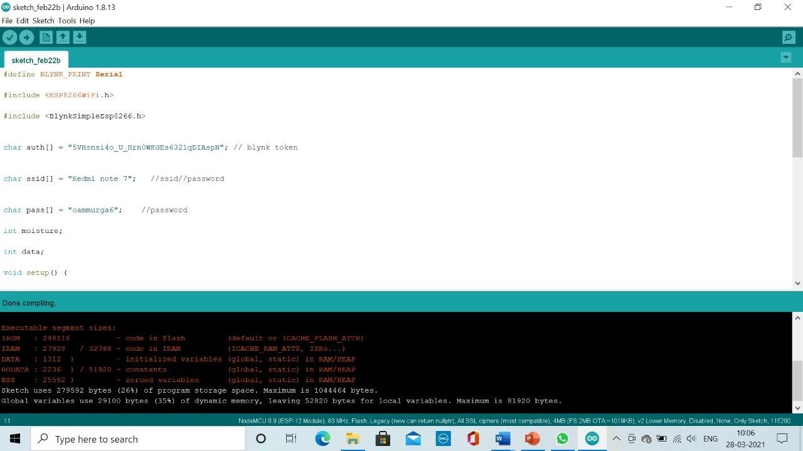

### Fig.3.5 Source Code

Fig.3.5 shows the Arduino IDE which has the source code to be dumped in Nodemcu to perform the work flow. After the verification of the code, the code is uploaded to the Nodemcu.

### BLYNK APP:

Download the Blynk App from play store in user's mobile. open the app, Give the mail_id and click on new project, give the project name as "smart Irrigation" and select the device as NodeMCU and select the connection Type as "Wifi".Next click "CREATE" button. The authentication code was sent to the mail . Auth token will be generated this auth token you will get in the settings option of this project and on our Gmail Account.

Once your project is created, we have to insert different types of widget into it, For example we will be adding a button from widget box shown below. we have also added a gauge button which will display moisture level of soil .so we gave moisture as name and selected pin as V5 and click ok. Next add a button and select D1 because we connected the relay module to D1 .And we gave name as “Pump”. To get a

notification from it we need to add the notification button and also add event button so after that click on add a new event , when moisture V5 is lower than 10 turn on D1 also send notification Pump activated. And also add one more event when moisture V5 is higher than 15 turn off D1.That means whenever moisture goes below 10 the pump will automatically turn on and it will send notification and also whenever the moisture goes higher than 15 motor will turn off .

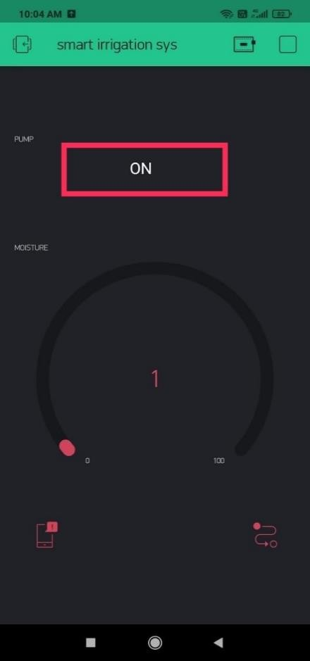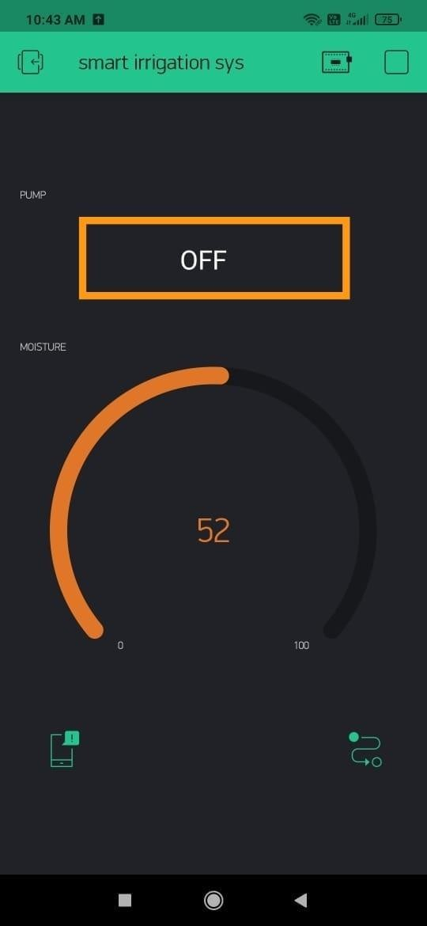

### Fig.3.6 Moisture less than 10 Fig.3.7 Moisture greater than 15

Fig.3.6 shows the moisture content in the gauge is less than 10, that is 1. This denotes that the soil is dry and the plant is need of water.so we have to turn ON the pump.

Fig.3.7 shows the moisture content in the gauge is greater than 15, which means that the soil is wet, so whether we can ON or OFF the pump depending upon the plants.

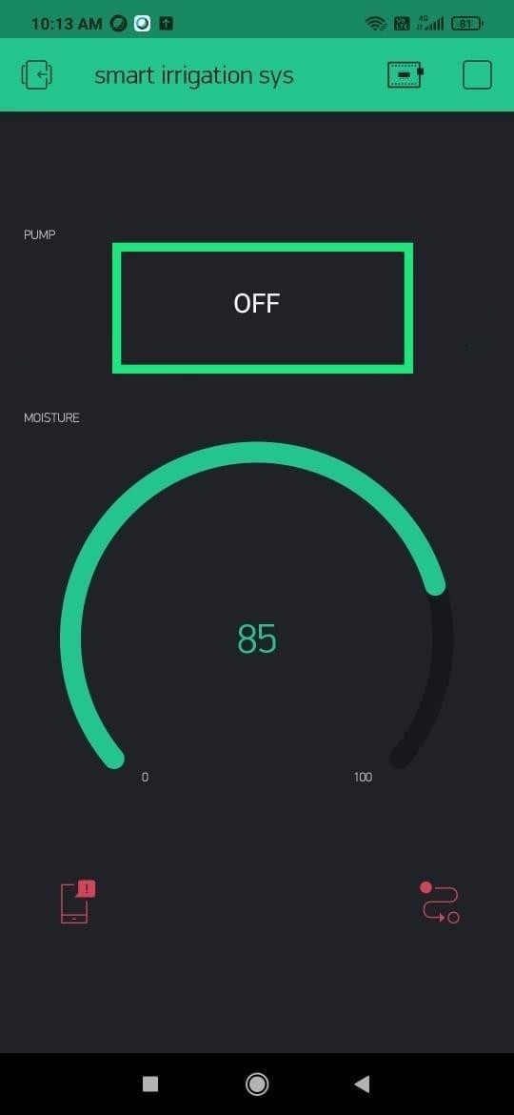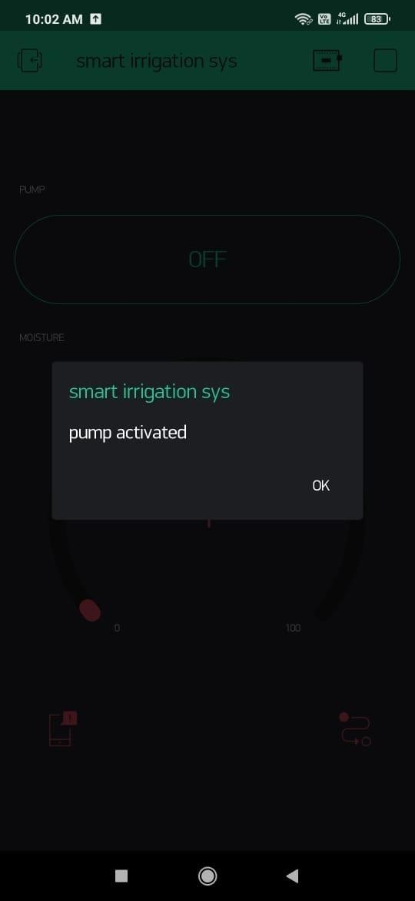

### Fig.3.8 Moisture Is greater than 60 Fig.3.9 Pump Activated

Fig.3.8 shows the gauge which represents the moisture content which is greater than 60, which means that the water is more than enough for the plant.in this situation, the user should turn OFF the pump.

Fig.3.9 shows the notification ”pump activated” which denotes the pump is turned ON when the soil is dry.

### HARDWARE CONNECTIONS:

A moisture sensor which is a LM393 comparator based sensor.it has four pins such as VCC, GND, analog output, digital output. Here we are using the analog output. The analog value changes according to the moisture (ie..,) when moisture increases the conductivity also increases. The other components are 2-channel relay board, ESP8266 Nodemcu, water pump 5v.

### CONNECTIONS:

1. Sensor to Nodemcu GND->GND

VCC->3v

analog output->analog input

Firstly the soil moisture sensor is connected to the Nodemcu. The GND pin is connected to the GND of Nodemcu, then the power supply(VCC) of sensor is connected to the 3V pin of Nodemcu, The analog output pin of sensor is connected to the analog input pin of Nodemcu.

1. Relay module to Nodemcu VCC->3v

GND->GND

relay input->digital input pin 1

The relay module is connected to the nodemcu. The VCC is connected to the 3V pin of nodemcu. The GND pin of relay module is connected to the GND of nodemcu. The relay input pin of relay is connected to the digital input pin of nodemcu.

1. Water pump to relay module

For water pump the external 7.4V battery is used

### WORK FLOW:

The soil moisture sensor kept in the soil senses the soil moisture regularly and sends the sensed data to the Nodemcu. The Embedded C program that is already uploaded into the Nodemcu contains the threshold value of moisture. The moisture must always be within the range in order to maintain the crop from damage. When the sensed value is found to be less than the value mentioned in the code, that is, if the moisture content in the soil is less than the threshold value, the control on the system is transferred to the relay module which performs the switching operation. The relay module now turns on the switch which allows the flow of water. The soil moisture sensor continues to sense the amount of moisture and when the field is provided with sufficient water, the relay module turns off the switch thereby preventing over-irrigation.

### MERITS & DEMERITS:

* + 1. **MERITS:**

It could be a useful method for water conservation preparation and irrigation scheduling, and it could be applied to other related agricultural crops. By tracking soil moisture, this device can also regulate the amount of water supplied to the plants when it is required, based on the types of plants. This project can be implemented in large agricultural areas where human effort is needed. For a plant requirement, many aspects of the system can be customized and fine-tuned using software.

### DEMERITS:

Since component failure has become a serious problem, the working state of each component must be tested on a regular basis. Other concerns include the farmer's lack of understanding of the system's current condition. Other concerns include the farmer's lack of understanding of the system's current state. At regular intervals, the farmer must visit the field to inspect the system's state.

## CHAPTER 4 RESULTS

The smart irrigation system was tested on a plant. In the Arduino code, the moisture range was set as 0-100, providing optimum condition for plant growth. Moreover, this system proves to be cost effective and proficient in conserving water and reducing its wastage.

The below figure Fig.3.10 shows the components which are connected in the bread board and also the relay module, water pump which are connected together for switching operations.

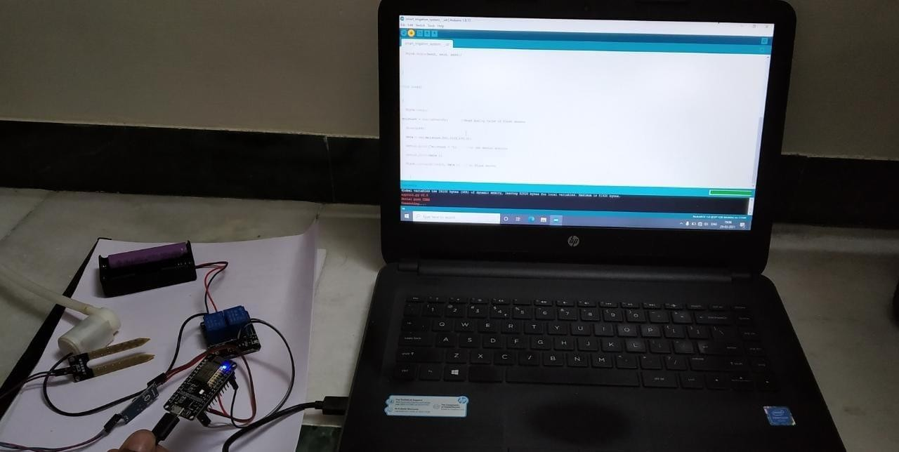

### Fig.3.10 Connections

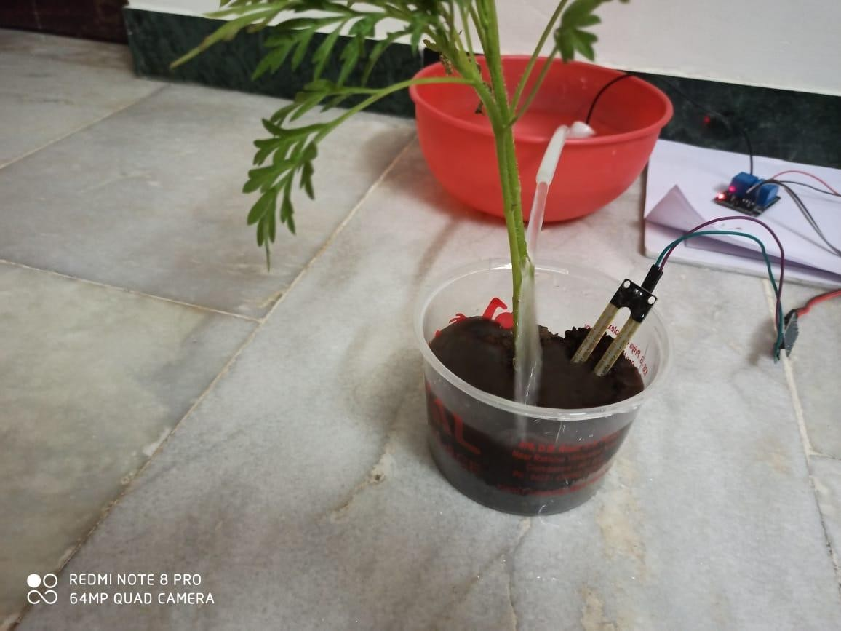

**Fig.3.11 IMPLEMENTATION**

Fig 3.11 shows the implementation of proposed system which represents the watering of soil when the moisture content is below the threshold value. This irrigation or water flow is controlled by the relay module which performs the switching operations ON and OFF.

## CHAPTER 5 CONCLUSION

Farmers in the modern period use a manual irrigation technique in which they irrigate the land at regular intervals. This procedure appears to be time-consuming

.Water wastage occurs as a result of using more water. Furthermore, in a dry climate, Irrigation becomes necessary in areas where rainfall is insufficient .As a result, we'll need an automated system, that precisely track and regulate the amount of water required in the field Installing a smart irrigation system will help you save time and money. This system ensures that water is used wisely. Furthermore, this structure Nodemcu is used, which guarantees a 20% improvement in machine life by lowering the power consumption It also lowers the human intervention ,therefore less energy of the farmer is required.

The smart irrigation system extends watering time for plants, and provides ideal growth condition. It saves time and timer delay as per the environmental condition can be added for automatic watering. This smart irrigation system can be adjusted and modified according to the changing environment.

### REFERENCES:

1. Aadithyan V, T Sai Samrat Goud, G Karthik Reddy, P Naga Chaitanya, V Jaya Surya, Dr K Prabhakara Rao "Smart Irrigation System Based on NodeMCU" IOSR Journal of Electronics and Communication Engineering (IOSR-JECE) e-ISSN: 2278-2834,p- ISSN: 2278-8735.Volume 14, Issue 5, Ser. I (Sep.-Oct. 2019), PP 01-04
2. Meghana Gupta Arakere, Avik Seal and Tejomurthula Bhuvana Teja(2019) “Smart irrigation system using IoT”, Asian Journal of Science and

Technology, 09, (06), 9756-9768.

1. Pavankumar Naik,Arun Kumbi ,Kirthishree Katti,Nagaraj Telkar "AUTOMATION OF IRRIGATION SYSTEM USING IoT" International Journal of Engineering and Manufacturing Science. ISSN 2249-3115 Volume 8, Number 1 (2018) pp. 77-88.

Premalatha C "Automatic Smart Irrigation System Using IOT" International Journal of Scientific Research in Computer Science and Engineering

Vol.7, Issue.1, pp.1-5, February (2019).